
Employee Evaluation of H S M PERERA Year : 2016

General Information
Employee Name | : | HEWAKANKANAMAGE SUPUN MIHINDU PERERA
NIC/SLIN | : | 197411800545
Service & Grade | : | SLAS – Grade III
Salary Code & Step | : | SL-2-2006 Step 12
Current Designation | : | Assistant Director (IT)
Current Organization | : | Ministry of Public Management Reforms
Joined Public Service | : | 1999/01/01
Date of Permanent Appointment | : | 2005/01/01

Education
Examination | Year | Result
GCE O/L | 1990 | D7 S1
GCE A/L | 1993 | A1 B2 C1
BSc | 2007 | Class II (Lower) in Computer Science

Professional Qualifications
Qualification | Year | Institute | Achievement/Notes
Professional Membership | 1997 | CSSL
Professional Membership | 1997 | CSSL | Upgraded to Professional Statues

Training
Program | Organization | Year | Feedback | Impact on Work
SLAS Induction | SLIDA | 1999 | Successfully completed | Knowledge on how to balance rules with service
Review by:  Harin Gunawardena | Review date:  2017-07-23 | Need to improve on people skills
Computer training course | Local Nenasala | 1998 | Certificate obtained | Ability use computers in line of duty
Review by:  Harin Gunawardena | Review date:  2017-07-23 | This is a basic requirement. You are advised to follow an advanced course.
e-Governance Training | ICTA | 2011 | Successfully completed | Effective usage of ICT in public service
Review by:  Harin Gunawardena | Review date:  2017-07-23 | Pls use this skill in the upcoming e-HRM implementation. You will be nominated as a key resource person.

Comments/Notes

Training
Responsibility | Period From | Period To | Learning Experience
Covered for Deputy Director of IT | 2014-05 | 2015-08 | Covered all duties of DDIT during his overseas training
Review by:  Harin Gunawardena | Review date:  2017-07-23 | Mr Perera effectively covered the DDIT duties at a time of need. No issues were encountered during the period.
Process Owner in e-HRM BPR Study | 2013-02 | 2014-07 | 1. Learned BPR activities  2. Learned problems faced by other departments in service provision
Review by:  Harin Gunawardena | Review date:  2017-07-23 | Mr Perera helped in the BPR study project for e-HRM solution. He must be assigned a role in the implementation stage too.

Comments/Notes

Areas of Interest
Area of Interest | Current Progress | Future Expectation | Target Year
e-Governance | Participated in BPR Studies | Implement e-HRM Solution | 2018
Review by:  Harin Gunawardena | Review date:  2017-07-23 | Mr Perera helped in the BPR study project for e-HRM solution. He must be assigned a role in the implementation stage too.
Quality enhancement of Public Service | Implemented S5 in my department | Conduct awareness in Public Service quality | 2017
Review by:  Harin Gunawardena | Review date:  2017-07-23 | Introduction of S5 is a good initiative. However, you must ensure continuity of the concept.  Several of the units are not fully compliant.

Comments/Notes

Career Plan
Goal Set by | Planned Goal | Current Progress | Planned Activities | Target Year
Supervisor | Complete BSc in Computer Science/ICT for next promotion | Successfully Completed | N/A | 2008
Review by:  Harin Gunawardena | Review date:  2017-07-23 | An MSc in this field is essential for the next promotion.
Employer | Complete MSc in IT for next promotion | Registered for MSc @ UCSC | 1. Complete study plan  2. Start final thesis | 2018
Review by:  Harin Gunawardena | Review date:  2017-07-23 | Good initiative. Pls try to include e-governance if possible
Employee | Conduct research on ICT and HRM | Research questionnaire preparation completed | 1. Conduct workshop to gather data  2. Analyze research results | 2017
Review by:  Harin Gunawardena | Review date:  2017-07-23 | This ia a good initiative. Pls include areas for improvement so that we can address them in e-HRM implementation

Comments/Notes

Feedback Analysis – for Previous 1 year
Source | Area of Evaluation | Rating | Details
Customer | Service Quality | 8.6/10 | 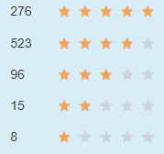
Customer | Response Time | 9.1/10 | 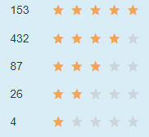
Supervisors | Work Quality | 8.8/10 | 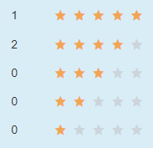
Peers | Team Spirit | 8.9/10 | 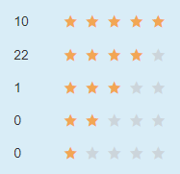
Peers | Domain Knowledge | 9.5/10 | 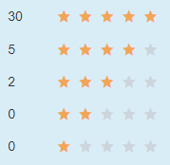
Subordinates | Leadership | 7.5/10 | 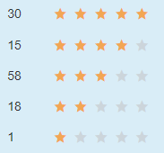
Subordinates | Fairness | 9.1/10 | 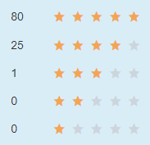

Comments/Notes

